Name:_________________
8.NS.1 Give examples of rational and irrational numbers and explain the difference between them.
Understand that every number has a decimal expansion;
- For each number write if the number is RATIONAL or IRRATIONAL and EXPLAIN (1-2 sentences) how you know.
- 5/6

- .327…

- √37

- Convert 9/11 to a decimal. Is it repeating or terminating? Show work to justify your answer.

8.NS.2 Use rational approximations of irrational numbers to compare the size of irrational numbers, plot them approximately on a number line, and estimate the value of expressions involving irrational numbers

- Estimate the location of the following rational and/or irrational numbers on a numberline

√5 6.25… ¼ -8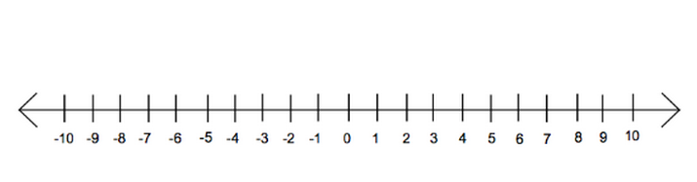

- Compare the following using the symbols < > =

√15 5 ½

2.345… √4

7/8 .9456906

