Unit 3 Study Guide: Equations and the Coordinate Grid
*Keep this study guide in the front of your binder throughout unit 3. Add to the resources, notes, and examples as we go!*
Learning Target | Resources | Notes | Examples
8.EE.5-I can graph a proportional relationship in the coordinate plane. (K) | SB Act. 3.1 |  | Determine if the following data sets are linear or non-linear. Use graph paper if needed:  - (2,-3)(4,-2)(-2,-5)(0,4)  - (0,5)(4,-3)(3,-1)(2,1)
8.EE.5-I can use a graph, table, and an equation to determine the unit rate of a proportional relationship and use the unit rate to make comparisons between various proportional relationships. (R) | SB Act. 3.1 |  | Determine the unit rate of the equation and table below. How does the unit rate of the table compare to the equation?  x y  1 -8  3 -4  5 0  y = -2x - 12
8.EE.5- I can interpret the unit rate or rate of change of a proportional relationship as the slope of the graph. (R) | SB Act. 3.3 |  | Determine the unit rate (slope) of the graph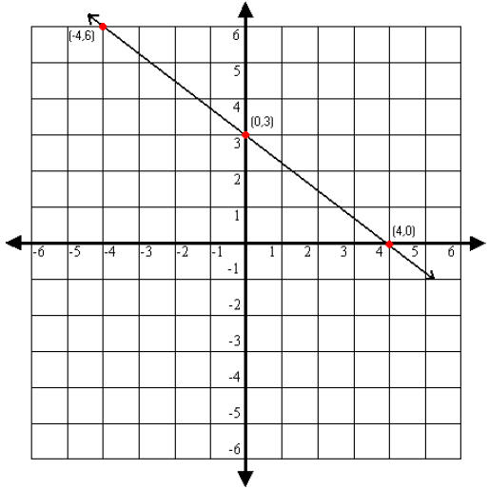
8.EE.6- I can justify that an equation in the form y=mx + b represents the graph of a linear relationship with a slope (rate of change) of m and a y-intercept (initial value) of b. (R) | SB Act. 3.4 and 3.5 |  | Identify the slope and y-intercept in the linear equation below. Describe how you would use these to graph the line. y = 5x – 2
8.EE.6- I can use similar, right triangles to justify that the slope (rate of change) is the same between any points on a non-vertical line. | Slope and Similar triangles packet |  | Determine if the following points lie on the same non-vertical line by determining if the slope is the same between them.  (2,3) (4,2) (8,0)
8.EE.8- I can use the graph of two linear equations to estimate the solution of the system. (S) | SB Act. 3.7 |  | Describe the graph of systems with…  No solution:  One solution:  No solution:
8.EE.8- I can explain how the point(s) of intersection of two graphs will represent the solution to the system of linear equations.(R) | SB Act. 3.7 |  | Solve the following system by graphing. Give the solution:  y = 3x + 2  y = -2x – 8
8.EE.8- I can use algebraic reasoning (simple substitution) and the properties of real numbers to solve a system of linear equations. (R) | SB Act. 3.7 |  | Solve the following system algebraically:  y = -3x + 6  3x + y = 5

