Unit 3 Study Guide: Equations and the Coordinate Grid
*Keep this study guide in the front of your binder throughout unit 3. Add to the resources, notes, and examples as we go!*
Learning Target | Resources | Notes | Examples
8.EE.5-I can graph a proportional relationship in the coordinate plane. (K) | SB Act. 3.1 | http://www.ixl.com/math/grade-8/identify-linear-and-nonlinear-functions (From a graph)  http://www.ixl.com/math/grade-8/identify-linear-and-nonlinear-functions (From a table)  http://betterlesson.com/community/document/1423279/linear-vs-nonlinear-docx (Click through linear and non linear examples in the document) | Determine if the following data sets are linear or non-linear. Use graph paper if needed:  - (2,-3)(4,-2)(-2,-5)(0,4)  - (0,5)(4,-3)(3,-1)(2,1)
8.EE.5-I can use a graph, table, and an equation to determine the unit rate of a proportional relationship and use the unit rate to make comparisons between various proportional relationships. (R) | SB Act. 3.1 | *Be able to calculate the Slope of the line given a table.  http://stricklerwms.weebly.com/uploads/1/1/3/7/11371633/8.ee.5_pretest.pdf (We completed this worksheet in class) | Determine the unit rate of the equation and table below. How does the unit rate of the table compare to the equation?  x y  1 -8  3 -4  5 0  y = -2x - 12
8.EE.5- I can interpret the unit rate or rate of change of a proportional relationship as the slope of the graph. (R) | SB Act. 3.3 | https://learnzillion.com/lessons/3219-determine-the-unit-rate-of-a-proportional-relationship-using-a-graph (Video that has unit rate given a graph) | Determine the unit rate (slope) of the graph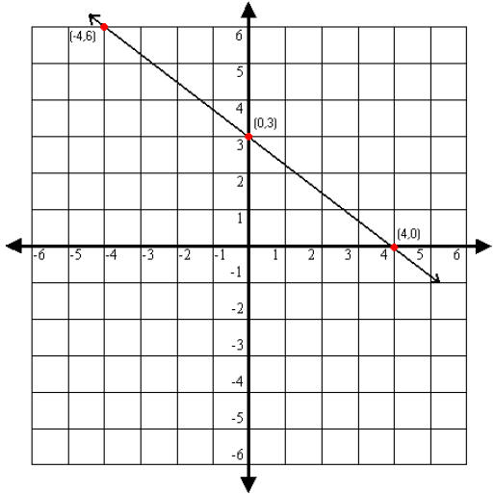
8.EE.6- I can justify that an equation in the form y=mx + b represents the graph of a linear relationship with a slope (rate of change) of m and a y-intercept (initial value) of b. (R) | SB Act. 3.4 and 3.5 | http://www.virtualnerd.com/tutorials/?id=Alg1_10_1_41  (how to make a quick graph with SLOPE (move) and Y INTERCEPT (begin)  http://www.ixl.com/math/algebra-1/slope-intercept-form-graph-an-equation (Practice-you plot the y intercept and the slope)  http://www.xpmath.com/forums/arcade.php?do=play&gameid=86 (Halo game graphing slope and y intercept) | Identify the slope and y-intercept in the linear equation below. Describe how you would use these to graph the line.  y = 5x – 2
8.EE.6- I can use similar, right triangles to justify that the slope (rate of change) is the same between any points on a non-vertical line. | Slope and Similar triangles packet | http://betterlesson.com/community/document/1423279/linear-vs-nonlinear-docx (Mario Slope)  KickerBoard Ramp Activity (Webquest)  http://www.mathwarehouse.com/algebra/linear_equation/interactive-slope.php (Scroll down and find the Interactive Rise/Run Slope and Similar Triangle Link.)  http://stricklerwms.weebly.com/8ee6-find-the-equation-of-a-line.html (visit the LINEAR EQUATION PLAYGROUND) for practice games. | 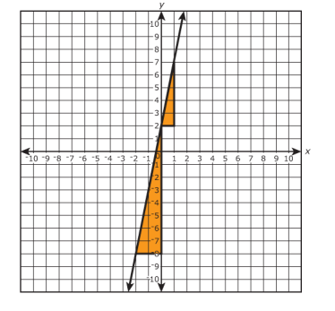  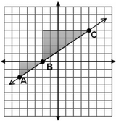
8.EE.8- I can use the graph of two linear equations to estimate the solution of the system. (S) | SB Act. 3.7 | http://mrallens.wikispaces.com/file/view/U5%20-%201%20notes%20answers.pdf/386519728/U5%20-%201%20notes%20answers.pdf (Notes with answers and examples of one solution no solution infinite)  Webquest Powerpoint (Solution) mrsfischer8.weebly.com http://mrsfischer8.weebly.com/thursday-feb-5-15.html | Describe the graph of systems with…  No solution:  One solution:  No solution:
8.EE.8- I can explain how the point(s) of intersection of two graphs will represent the solution to the system of linear equations.(R) | SB Act. 3.7 | http://www.ixl.com/math/algebra-1/solve-a-system-of-equations-by-graphing (PRactice graphing systems) | Solve the following system by graphing. Give the solution:  y = 3x + 2  y = -2x – 8
8.EE.8- I can use algebraic reasoning (simple substitution) and the properties of real numbers to solve a system of linear equations. (R) | SB Act. 3.7 | http://mrallens.wikispaces.com/file/view/U5%20-%203%20notes%20answers.pdf/386519856/U5%20-%203%20notes%20answers.pdf (examples on this ANSWER key with solivng systems using substitution) | Solve the following system algebraically:  y = -3x + 6  3x + y = 5  Y=-x+4  Y=x-2
http://mrsfischer8.weebly.com/slope-powerpoint.html Slope Powerpoint-under FLEX and LINEAR INVESTIGATIOn under flex.

