Part I.Visit the link: http://www.learnalberta.ca/content/mejhm/index.html?l=0&ID1=AB.MATH.JR.SHAP&ID2=AB.MATH.JR.SHAP.SURF&lesson=html/object_interactives/surfaceArea/use_it.html
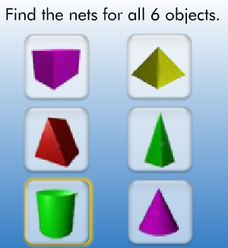
1.Define the term NET________________________________________________________________
2. Sketch the NET for a CONE, CYLINDER and RECTANGULAR PRISM BELOW.

PartII. Visit the link and use the interactive tool to solve the missing values.
http://www.learnalberta.ca/content/mejhm/index.html?l=0&ID1=AB.MATH.JR.SHAP&ID2=AB.MATH.JR.SHAP.SURF&lesson=html/video_interactives/areavolume/areaVolumeInteractive.html 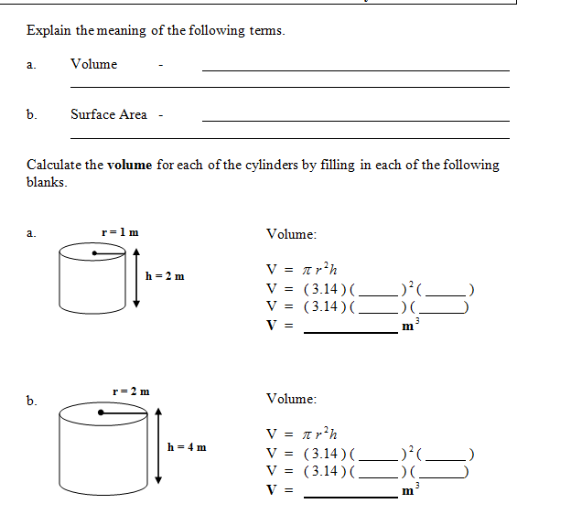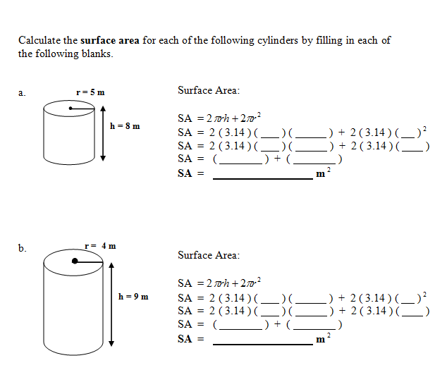
4. Video Real World (watch the clip) http://www.learnalberta.ca/content/mejhm/index.html?l=0&ID1=AB.MATH.JR.SHAP&ID2=AB.MATH.JR.SHAP.SURF&lesson=html/video_interactives/areavolume/areaVolumeSmall.html
Part III. Visit the link http://www.learner.org/interactives/geometry/3d_prisms.html
Click on Rectangular Prism
- How many Faces, Vertices and Edges does a Rectangular Prism have? Explain what each term means.

- Use the interactive tool to list the name of ANOTHER prism and include how many faces, edges and vertices that it has.

Part IV: Visit the link: https://www.brainingcamp.com/legacy/content/concepts/surface-area/lesson.php
Watch the lesson to review surface area, try the manipulative and ANSWER THE REAL WOLRD QUESTIONS. SHOW YOUR WORK!
7.________________Cardboard Box
8.________________Pharoh Casket
9._________________Earth
10._________________Label
11. ________________Tent

Additional Resources:
http://www.quia.com/rr/552915.html?AP_rancd=1008416330

http://www.asset.asu.edu/new/mathactive/lessons/30/interface-nets.swf

http://www.asset.asu.edu/new/mathactive/lessons/63/interface-cone.swf

