Part I-Transversal Vocabulary
LT: I can make conjectures regarding the relationships and measurements of the angles created when 2 parallel lines are cut by a transversal (8G5A)
Visit the website http://www.learnalberta.ca/content/mejhm/index.html?l=0&ID1=AB.MATH.JR.SHAP&ID2=AB.MATH.JR.SHAP.ANG&lesson=html/object_interactives/parallel_lines/use_it.html
Click on: EXPLORING PARALLEL LINES OBJECT INTERACTIVE. (collect the tokens and drive to the pet store).
Record your work here(examples etc.)
Part II.-Angle Sum Theory
LT: I can apply my knowledge of the angle sum and exterior angle of triangles to calculate missing angle measures(8G5C)
Visit the website http://www.learnalberta.ca/content/mejhm/index.html?l=0&ID1=AB.MATH.JR.SHAP&ID2=AB.MATH.JR.SHAP.ANG&lesson=html/video_interactives/angles/anglesInteractive.html 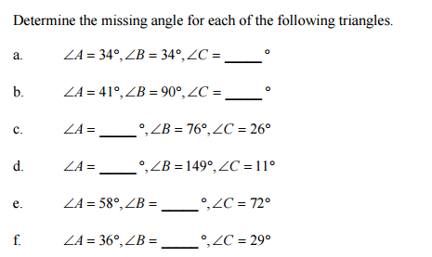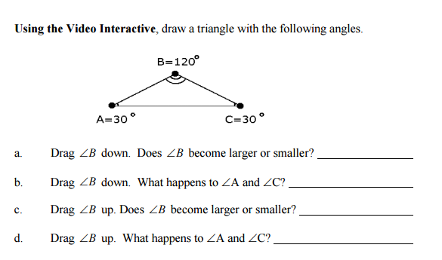
Part III-INDIRECT MEASUREMENT (NEW)
LT: I can justify that 2 triangles are similar comparing corresponding angle measures 8.G5B
Visit: http://www.virtualnerd.com/geometry/similarity/triangles/indirect-measurement-example
Watch the video.
Visit: https://www.ket.org/scalecity/louisvillesluggermuseum.html
Click: SIMILAR SHADOWS ACTIVITY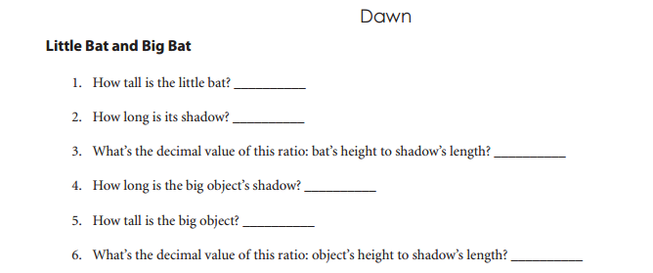
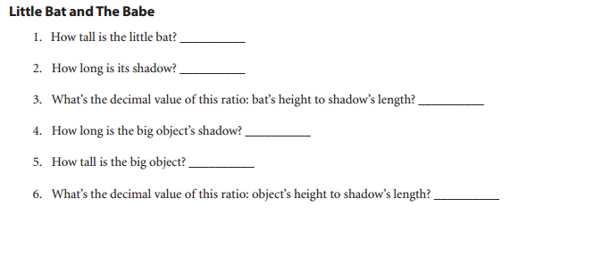Turn in the WEBQUEST when you are finished.
Please get a copy of the homework (review)

